Assignment 8 (Week 8)
- Perform an error check of the schematic by clicking in menu on Inspect → Electrical Rules Checker. Fix the errors which you can. If it is not an error or it is not possible to fix, write a justification for every case.
Done, please see the attached KiCad project folder
- Describe the process of designing a PCBA for turnkey product with detailed outcomes at each step.
  - Understand the electrical parameters
    - Before starting a PCB design, you should know and understand the electrical parameters of the system, including current maximums, voltages, signal types, capacitance limitations, impedance characteristics, etc.
  - Creating the schematic
  - Use a schematic capture tool to create your PCB layout
  - Design your PCB stackup
    - This is important to consider early on in the PCB design stage due to impedance, which refers to how much and how quickly electricity can travel down a trace. The stackup plays a role in how the mechanical engineer can design and fit the PCB into the device.
  - Define design rules and requirements
    - This step is largely dictated by standards and acceptability criteria from the IPC, which is the industry association for PCB and electronics manufacturing.
  - Place your components
    - In many cases, the customer and PCB provider will discuss design and layout guidelines
  - Insert drill holes
  - Route the traces
  - Add labels and identifiers
  - Generate design/layout files
    - This is the final step in the layout process. These files contain all the information pertaining to your printed circuit board, and once they have been generated, your PCB is now ready for manufacturing.
- Create a schematic in LTSpice to simulate User Pushbutton B2 (from page 10 of the STM board schematic) opening process. Run simulation for 30ms and read the voltage on the BUTTON_EXTI13 (or SB3) at 10, 20 and 30ms.
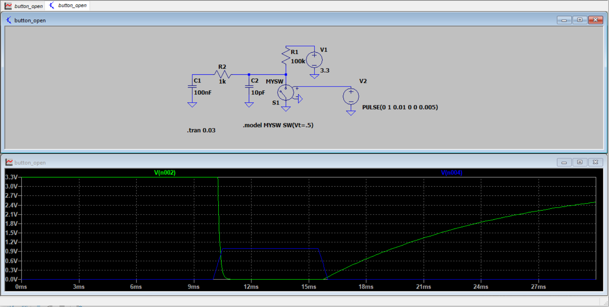
I use voltage control switch to simulate the push button and set the voltage threshold to 0.5v, so it can simulate the close and open correctly since my supply voltage on value is 1v. Then I set the push button rise and fail time to 0 (the plot does not cover the button debouncing), and on time for 5ms. The green line is the result for BUTTON_EXTI13 (or SB3), and the blue line is for the voltage control switch. From the plot, at 10ms, the voltage value on BUTTON_EXTI13 (or SB3) is 3.3v, at 20ms, it is nearly 1.2v, and at 30ms, it is nearly 2.5v.

